Name: SIDDHANT DHAMDHERE
Roll no. 49
Class: BE B E&TC

JS Assignment

Q1) Write a javascript program which will print ‘Hello World’ in the body of the HTML document
Code:
<!DOCTYPE html>
<html lang="en">
<head>
<meta charset="UTF-8">
<meta name="viewport" content="width=device-width, initial-scale=1.0">
<title>Hello World Example</title>
</head>
<body>
<script>
document.write("Hello World");
</script>
</body>
</html>

Output;
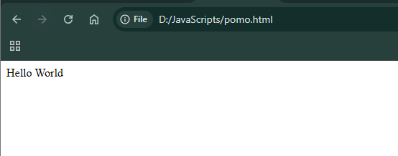

Q2) Write a JavaScript function that reverses a number, Example x = 32243; Expected Output: 34223
Code:
<!DOCTYPE html>
<html lang="en">
<head>
<meta charset="UTF-8">
<meta name="viewport" content="width=device-width, initial-scale=1.0">
<title>Reverse a Number</title>
</head>
<body>
<h2>Reverse a Number using JavaScript</h2>

<script>
function reverseNumber(x) {
// Convert number to string, split → reverse → join → convert back to number
let reversed = Number(x.toString().split('').reverse().join(''));
return reversed;
}

let x = 32243;
document.write("Original Number: " + x + "<br>");
document.write("Reversed Number: " + reverseNumber(x));
</script>
</body>
</html>

Output:
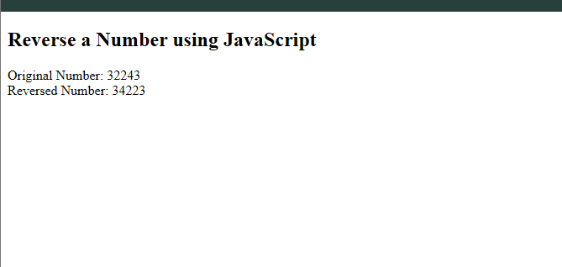

Q3)Write a JavaScript function that checks whether a passed string is palindrome or not?
Code:
<!DOCTYPE html>
<html lang="en">
<head>
<meta charset="UTF-8">
<meta name="viewport" content="width=device-width, initial-scale=1.0">
<title>Palindrome Checker</title>
<style>
body {
font-family: Arial, sans-serif;
background-color: #f4f8ff;
text-align: center;
padding-top: 60px;
}

input {
padding: 10px;
font-size: 16px;
border: 1px solid #ccc;
border-radius: 5px;
width: 200px;
}

button {
padding: 10px 20px;
font-size: 16px;
border: none;
border-radius: 6px;
background-color: #007bff;
color: white;
cursor: pointer;
margin-left: 10px;
}

button:hover {
background-color: #0056b3;
}

p {
font-size: 18px;
margin-top: 20px;
}
</style>
</head>
<body>

<h2>🔁 Palindrome Checker</h2>
<input type="text" id="userInput" placeholder="Enter a word">
<button onclick="checkPalindrome()">Check</button>

<p id="result"></p>

<script>
function checkPalindrome() {
let str = document.getElementById("userInput").value;

if (str.trim() === "") {
alert("Please enter a word!");
return;
}

let cleaned = str.toLowerCase().replace(/[^a-z0-9]/g, '');
let reversed = cleaned.split('').reverse().join('');

let result = document.getElementById("result");

if (cleaned === reversed) {
result.style.color = "green";
result.innerHTML = `✅ "${str}" is a Palindrome!`;
} else {
result.style.color = "red";
result.innerHTML = `❌ "${str}" is NOT a Palindrome.`;
}
}
</script>

</body>
</html>

Output:
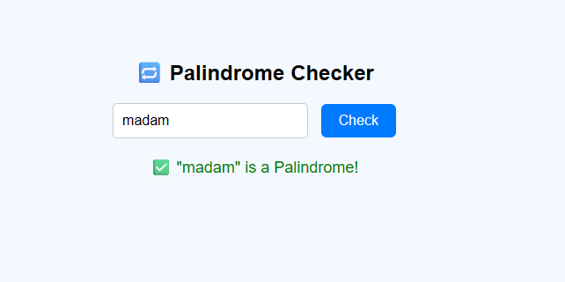

Q4) write a JavaScript function that accepts a string as a parameter and converts the first letter of each word of the string in upper case.
Code:
<!DOCTYPE html>
<html lang="en">
<head>
<meta charset="UTF-8">
<meta name="viewport" content="width=device-width, initial-scale=1.0">
<title>Capitalize Each Word</title>
<style>
body {
font-family: Arial, sans-serif;
background-color: #eef4ff;
text-align: center;
padding-top: 60px;
}

input {
padding: 10px;
width: 250px;
font-size: 16px;
border-radius: 5px;
border: 1px solid #ccc;
}

button {
padding: 10px 20px;
font-size: 16px;
border: none;
border-radius: 6px;
background-color: #007bff;
color: white;
cursor: pointer;
margin-left: 10px;
}

button:hover {
background-color: #0056b3;
}

p {
font-size: 18px;
margin-top: 20px;
}
</style>
</head>
<body>

<h2>📝 Convert First Letter of Each Word to Uppercase</h2>

<input type="text" id="userInput" placeholder="Enter a sentence">
<button onclick="convertToTitleCase()">Convert</button>

<p id="result"></p>

<script>
function capitalizeWords(str) {
// Split string into words, capitalize first letter of each, then join back
return str
.split(' ')
.map(word => word.charAt(0).toUpperCase() + word.slice(1).toLowerCase())
.join(' ');
}

function convertToTitleCase() {
let input = document.getElementById("userInput").value;

if (input.trim() === "") {
alert("Please enter a sentence!");
return;
}

let resultText = capitalizeWords(input);
document.getElementById("result").innerHTML =
`✅ Converted String: <strong>${resultText}</strong>`;
}
</script>

</body>
</html>

Output:
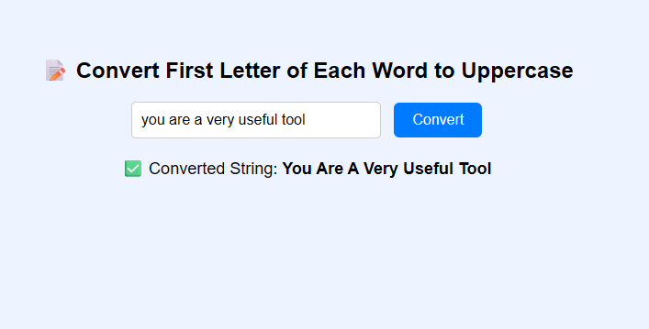

Assignment 2

1. Write a JavaScript program that displays the position of the first occurrence of "World" in the variable txt.
Html:
<!DOCTYPE html>
<html lang="en">
<head>
<meta charset="UTF-8">
<meta name="viewport" content="width=device-width, initial-scale=1.0">
<title>Find Position</title>
<style>
body {
font-family: Arial, sans-serif;
background-color: #f4f4f4;
display: flex;
justify-content: center;
align-items: center;
height: 100vh;
margin: 0;
flex-direction: column;
text-align: center;
}
.container {
background-color: #fff;
padding: 30px;
border-radius: 8px;
box-shadow: 0 4px 8px rgba(0,0,0,0.1);
max-width: 500px;
width: 100%;
}
h1 {
color: #333;
}
p {
font-size: 18px;
}
#result {
font-weight: bold;
color: #007BFF;
font-size: 20px;
margin-top: 10px;
}
</style>
</head>
<body>
<div class="container">
<h1>Find the Position of "World"</h1>
<p>The original string is: "Hello World"</p>
<p>The position of the first occurrence of "World" is:</p>
<p id="result"></p>
</div>
<script>
window.onload = function() {
let txt = "Hello World";
let position = txt.indexOf("World");
document.getElementById("result").innerText = position;
};
</script>
</body>
</html>

Output:
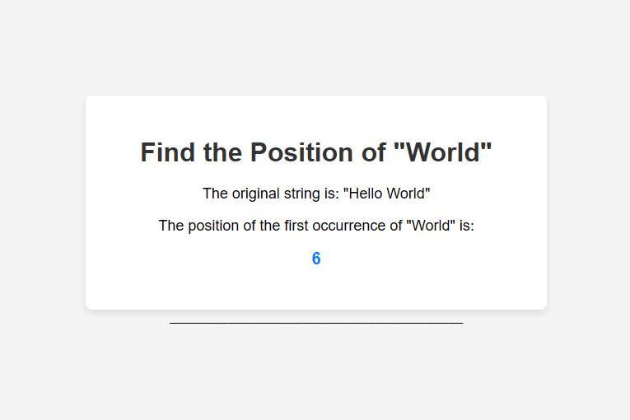
2. Write a JavaScript program that converts the text to upper case.
Html:
<!DOCTYPE html>
<html lang="en">
<head>
<meta charset="UTF-8">
<meta name="viewport" content="width=device-width, initial-scale=1.0">
<title>Convert to Upper Case</title>
<style>
body {
font-family: Arial, sans-serif;
background-color: #f4f4f4;
display: flex;
justify-content: center;
align-items: center;
height: 100vh;
margin: 0;
flex-direction: column;
text-align: center;
}
.container {
background-color: #fff;
padding: 30px;
border-radius: 8px;
box-shadow: 0 4px 8px rgba(0,0,0,0.1);
max-width: 500px;
width: 100%;
}
h1 {
color: #333;
}
p {
font-size: 18px;
}
#result {
font-weight: bold;
color: #dc3545;
font-size: 20px;
margin-top: 10px;
}
</style>
</head>
<body>
<div class="container">
<h1>Convert Text to Upper Case</h1>
<p>Original string: "Hello World!"</p>
<p>The uppercase string is:</p>
<p id="result"></p>
</div>
<script>
window.onload = function() {
let str = "Hello World!";
let upperCaseStr = str.toUpperCase();
document.getElementById("result").innerText = upperCaseStr;
};
</script>
</body>
</html>
Output:
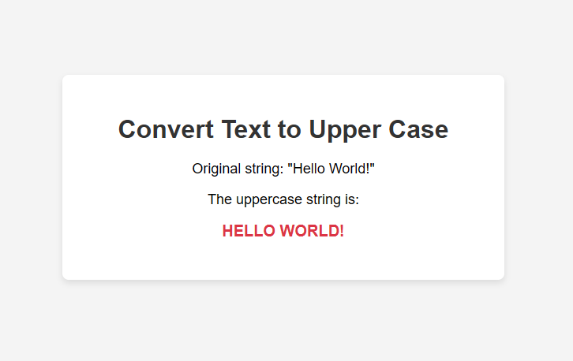

3. Write a JavaScript function to remove a specified number of characters from a string.
This example provides an HTML page with the JavaScript function included to demonstrate its usage.
Html:
<!DOCTYPE html>
<html lang="en">
<head>
<meta charset="UTF-8">
<meta name="viewport" content="width=device-width, initial-scale=1.0">
<title>Remove Characters</title>
<style>
body {
font-family: Arial, sans-serif;
background-color: #f4f4f4;
display: flex;
justify-content: center;
align-items: center;
height: 100vh;
margin: 0;
flex-direction: column;
text-align: center;
}
.container {
background-color: #fff;
padding: 30px;
border-radius: 8px;
box-shadow: 0 4px 8px rgba(0,0,0,0.1);
max-width: 500px;
width: 100%;
}
h1 {
color: #333;
}
p {
font-size: 18px;
}
button {
padding: 10px 20px;
background-color: #28a745;
color: white;
border: none;
border-radius: 4px;
cursor: pointer;
margin-top: 15px;
}
button:hover {
background-color: #218838;
}
#result {
font-weight: bold;
color: #007BFF;
font-size: 20px;
margin-top: 10px;
}
</style>
</head>
<body>
<div class="container">
<h1>Remove Characters from a String</h1>
<p>Original string: "JavaScript"</p>
<p>Removing the first 4 characters will result in:</p>
<p id="result"></p>
<button onclick="displayResult()">Show Result</button>
</div>
<script>
function removeChars(str, num) {
return str.slice(num);
}
function displayResult() {
let originalString = "JavaScript";
let newString = removeChars(originalString, 4); // Removes the first 4 characters
document.getElementById("result").innerText = newString;
}
</script>
</body>
</html>

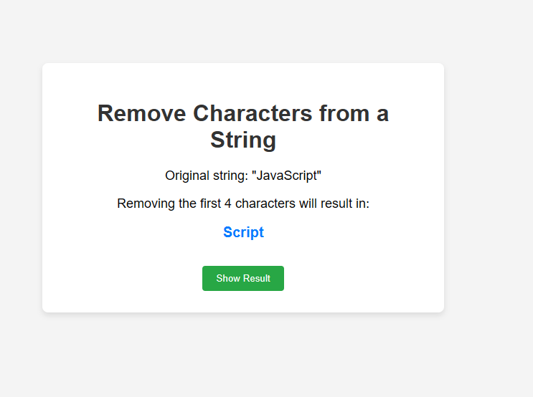
4. Create an HTML page with two textboxes and a Calculate button: When the user enters the numbers and clicks the Calculate button, it has to alert the sum.
Html:
<!DOCTYPE html>
<html lang="en">
<head>
<meta charset="UTF-8">
<meta name="viewport" content="width=device-width, initial-scale=1.0">
<title>Sum Calculator</title>
<style>
body {
font-family: Arial, sans-serif;
background-color: #f4f4f4;
display: flex;
justify-content: center;
align-items: center;
height: 100vh;
margin: 0;
flex-direction: column;
text-align: center;
}
.container {
background-color: #fff;
padding: 30px;
border-radius: 8px;
box-shadow: 0 4px 8px rgba(0,0,0,0.1);
max-width: 400px;
width: 100%;
}
h1 {
color: #333;
}
input[type="number"] {
width: 80%;
padding: 10px;
margin: 10px 0;
border: 1px solid #ccc;
border-radius: 4px;
font-size: 16px;
}
button {
padding: 10px 20px;
background-color: #007BFF;
color: white;
border: none;
border-radius: 4px;
cursor: pointer;
margin-top: 15px;
}
button:hover {
background-color: #0056b3;
}
#sumResult {
font-weight: bold;
color: #28a745;
font-size: 20px;
margin-top: 10px;
}
</style>
</head>
<body>
<div class="container">
<h1>Sum Calculator</h1>
<input type="number" id="num1" placeholder="Enter first number">
<input type="number" id="num2" placeholder="Enter second number">
<button onclick="calculateSum()">Calculate</button>
<p id="sumResult"></p>
</div>
<script>
function calculateSum() {
let num1 = parseFloat(document.getElementById("num1").value) || 0;
let num2 = parseFloat(document.getElementById("num2").value) || 0;
let sum = num1 + num2;
document.getElementById("sumResult").innerText = "The sum is: " + sum;
}
</script>
</body>
</html>

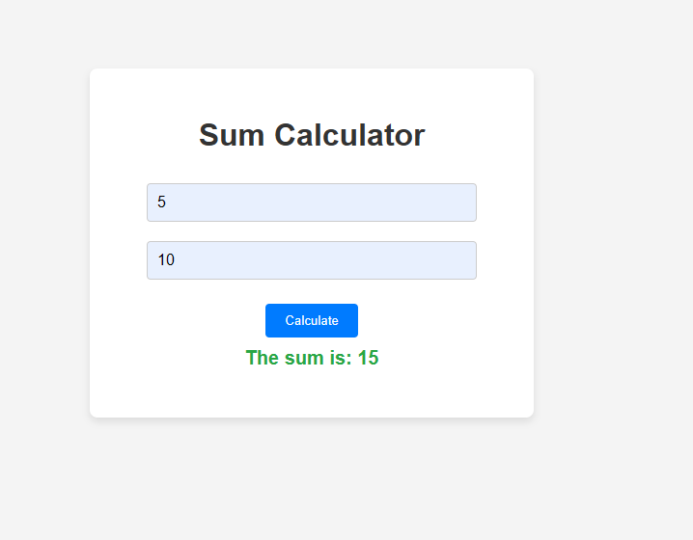
5. Write a JavaScript program which will have one textbox to get input as a string and after giving input when you leave the input textbox, a function is triggered which transforms the input text to uppercase.
<!DOCTYPE html>
<html lang="en">
<head>
<meta charset="UTF-8">
<meta name="viewport" content="width=device-width, initial-scale=1.0">
<title>Uppercase Converter</title>
<style>
body {
font-family: Arial, sans-serif;
background-color: #f4f4f4;
display: flex;
justify-content: center;
align-items: center;
height: 100vh;
margin: 0;
flex-direction: column;
text-align: center;
}
.container {
background-color: #fff;
padding: 30px;
border-radius: 8px;
box-shadow: 0 4px 8px rgba(0,0,0,0.1);
max-width: 400px;
width: 100%;
}
h1 {
color: #333;
}
input {
width: 80%;
padding: 10px;
margin: 10px 0;
border: 1px solid #ccc;
border-radius: 4px;
font-size: 16px;
}
</style>
</head>
<body>
<div class="container">
<h1>Uppercase Converter</h1>
<p>Type something into the box and click away to see it convert to uppercase.</p>
<input type="text" id="myInput" onblur="convertToUppercase()">
</div>
<script>
function convertToUppercase() {
let x = document.getElementById("myInput");
x.value = x.value.toUpperCase();
}
</script>
</body>
</html>
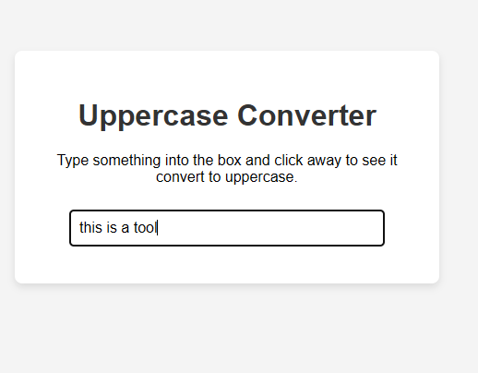

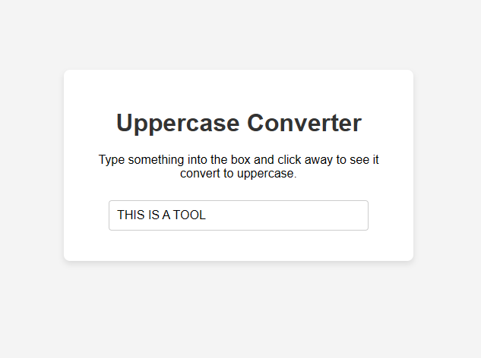
6. Create an HTML page with 4 hyperlinks named white, red, blue and pink. The background color of the HTML page will change based on the link which is clicked. Write a javascript function to implement it.
Html:
<!DOCTYPE html>
<html lang="en">
<head>
<meta charset="UTF-8">
<meta name="viewport" content="width=device-width, initial-scale=1.0">
<title>Background Changer</title>
<style>
body {
font-family: Arial, sans-serif;
text-align: center;
transition: background-color 0.5s ease;
height: 100vh;
display: flex;
flex-direction: column;
justify-content: center;
align-items: center;
margin: 0;
}
h1 {
color: #333;
}
p {
font-size: 18px;
color: #555;
}
.links {
margin-top: 20px;
}
.links a {
padding: 10px 20px;
margin: 0 10px;
text-decoration: none;
color: #333;
background-color: #f0f0f0;
border-radius: 5px;
transition: background-color 0.3s;
border: 1px solid #ccc;
}
.links a:hover {
background-color: #e0e0e0;
}
</style>
</head>
<body>
<h1>Change the Background Color</h1>
<p>Click on one of the links to change the page's background color.</p>
<div class="links">
<a href="#" onclick="changeBackground('white')">white</a>
<a href="#" onclick="changeBackground('red')">red</a>
<a href="#" onclick="changeBackground('blue')">blue</a>
<a href="#" onclick="changeBackground('pink')">pink</a>
</div>
<script>
function changeBackground(color) {
document.body.style.backgroundColor = color;
}
</script>
</body>
</html>
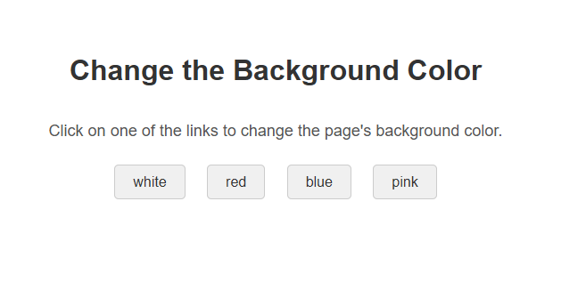
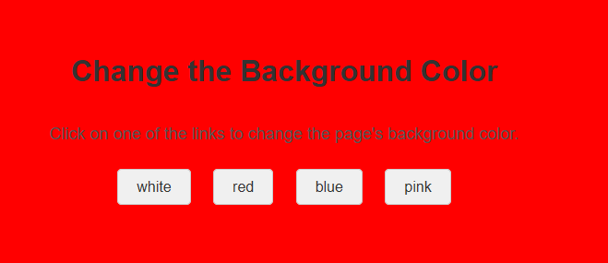

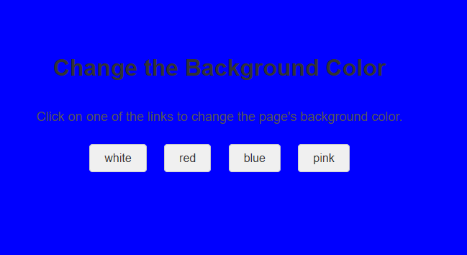
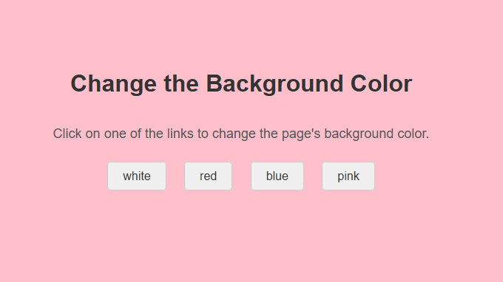

7. Write a JavaScript program which will:
a. give an alert message of today's date.
b. prompt the user to give their name and gives an alert message 'Hello' and username.
c. prompt the user to give 2 numbers and alerts the sum of those 2 numbers.

Html:
<!DOCTYPE html>
<html lang="en">
<head>
<meta charset="UTF-8">
<meta name="viewport" content="width=device-width, initial-scale=1.0">
<title>JavaScript Display Output</title>
<style>
body {
font-family: Arial, sans-serif;
background-color: #f0f2f5;
display: flex;
justify-content: center;
align-items: center;
flex-direction: column;
min-height: 100vh;
margin: 0;
padding: 20px;
}
.container {
background-color: #fff;
padding: 30px;
border-radius: 10px;
box-shadow: 0 4px 8px rgba(0, 0, 0, 0.1);
max-width: 600px;
width: 100%;
text-align: center;
}
h1, h2 {
color: #333;
}
button {
background-color: #007bff;
color: white;
border: none;
padding: 12px 24px;
margin: 10px;
border-radius: 5px;
cursor: pointer;
font-size: 16px;
transition: background-color 0.3s ease;
}
button:hover {
background-color: #0056b3;
}
p {
font-size: 18px;
color: #555;
margin: 10px 0;
}
.result-output {
font-weight: bold;
color: #28a745;
}
</style>
</head>
<body>
<div class="container">
<h1>JavaScript Output on Page</h1>

<h2>a. Today's Date</h2>
<p>Click the button to see today's date: <span id="dateOutput" class="result-output"></span></p>
<button onclick="displayDate()">Show Today's Date</button>

<h2>b. Greet User</h2>
<p>Click the button to enter your name and get a greeting: <span id="greetingOutput" class="result-output"></span></p>
<button onclick="greetUser()">Greet Me</button>

<h2>c. Sum of Two Numbers</h2>
<p>Click the button to enter two numbers and see their sum: <span id="sumOutput" class="result-output"></span></p>
<button onclick="sumNumbers()">Calculate Sum</button>
</div>

<script>
// a. Display today's date on the page
function displayDate() {
const today = new Date();
document.getElementById('dateOutput').innerText = today.toDateString();
}

// b. Prompt for name and display greeting
function greetUser() {
const userName = prompt("Please enter your name:");
if (userName) {
document.getElementById('greetingOutput').innerText = "Hello " + userName;
} else {
document.getElementById('greetingOutput').innerText = "Hello!";
}
}

// c. Prompt for two numbers and display their sum
function sumNumbers() {
const num1Str = prompt("Enter the first number:");
const num2Str = prompt("Enter the second number:");

const num1 = parseFloat(num1Str);
const num2 = parseFloat(num2Str);

if (!isNaN(num1) && !isNaN(num2)) {
const sum = num1 + num2;
document.getElementById('sumOutput').innerText = "The sum is: " + sum;
} else {
document.getElementById('sumOutput').innerText = "Invalid input. Please enter valid numbers.";
}
}
</script>
</body>
</html>

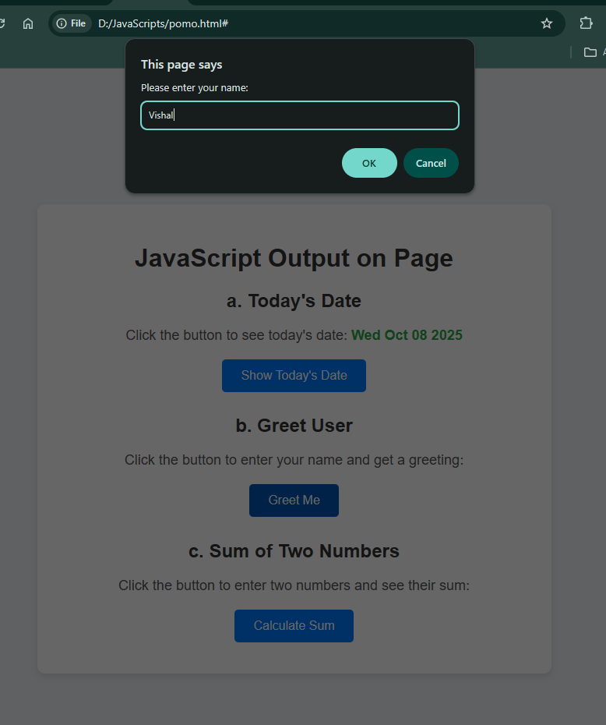
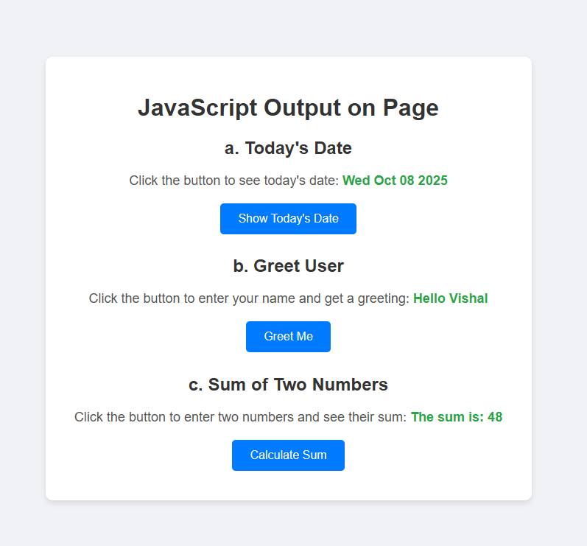

8. Write a JavaScript program that prompts the user to enter a number and display whether the number given is odd or even.
Html:
<!DOCTYPE html>
<html lang="en">
<head>
<meta charset="UTF-8">
<meta name="viewport" content="width=device-width, initial-scale=1.0">
<title>Odd or Even</title>
<style>
body {
font-family: Arial, sans-serif;
background-color: #e9ecef;
display: flex;
justify-content: center;
align-items: center;
flex-direction: column;
min-height: 100vh;
margin: 0;
padding: 20px;
}
.container {
background-color: #fff;
padding: 30px;
border-radius: 10px;
box-shadow: 0 4px 8px rgba(0, 0, 0, 0.1);
max-width: 500px;
width: 100%;
text-align: center;
}
h1 {
color: #343a40;
}
button {
background-color: #17a2b8;
color: white;
border: none;
padding: 12px 24px;
margin-top: 20px;
border-radius: 5px;
cursor: pointer;
font-size: 16px;
transition: background-color 0.3s ease;
}
button:hover {
background-color: #138496;
}
p {
font-size: 18px;
color: #555;
}
#result {
font-weight: bold;
margin-top: 15px;
color: #007bff;
}
</style>
</head>
<body>
<div class="container">
<h1>Check if a Number is Odd or Even</h1>
<p>Click the button to enter a number and find out if it's odd or even.</p>
<button onclick="checkOddOrEven()">Check Number</button>
<p id="result"></p>
</div>

<script>
function checkOddOrEven() {
const numberStr = prompt("Enter a number:");
const resultElement = document.getElementById('result');
const number = parseInt(numberStr);

if (!isNaN(number)) {
if (number % 2 === 0) {
resultElement.innerText = "The number " + number + " is even.";
} else {
resultElement.innerText = "The number " + number + " is odd.";
}
} else {
resultElement.innerText = "Invalid input. Please enter a valid number.";
}
}
</script>
</body>
</html>

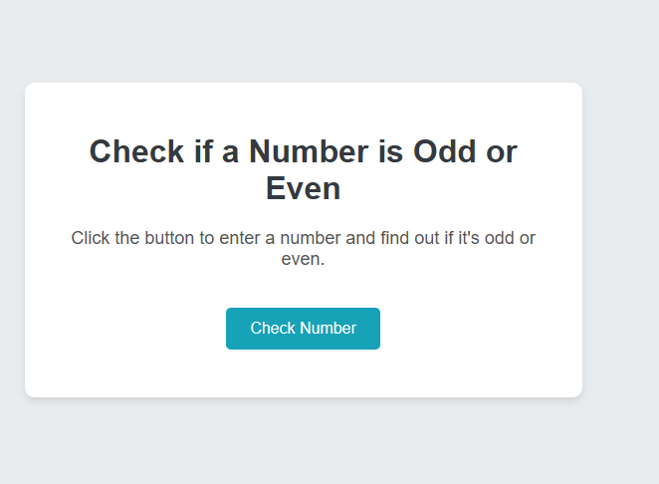
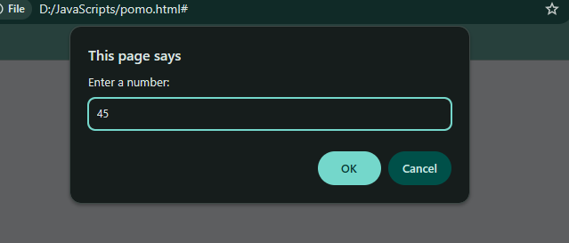
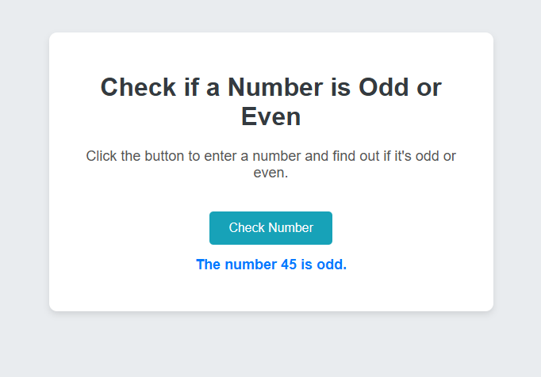
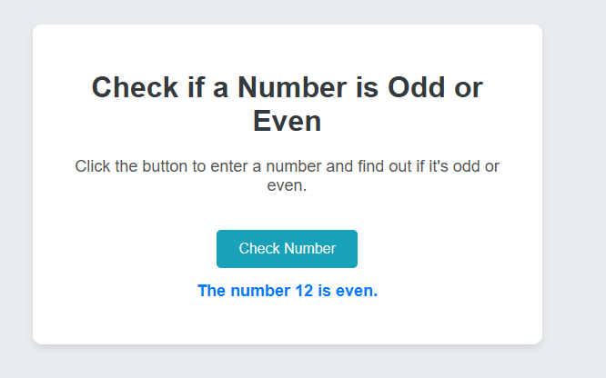

9. Create a program to display current time in a textbox (HH:MM:SS) such that the value in the time textbox is dynamic (Time should get updated every second) and not static.
Html:
<!DOCTYPE html>
<html lang="en">
<head>
<meta charset="UTF-8">
<meta name="viewport" content="width=device-width, initial-scale=1.0">
<title>Dynamic Time Display</title>
<style>
body {
font-family: Arial, sans-serif;
background-color: #f8f9fa;
display: flex;
justify-content: center;
align-items: center;
flex-direction: column;
min-height: 100vh;
margin: 0;
padding: 20px;
}
.container {
background-color: #fff;
padding: 30px;
border-radius: 10px;
box-shadow: 0 4px 8px rgba(0, 0, 0, 0.1);
max-width: 400px;
width: 100%;
text-align: center;
}
h1 {
color: #343a40;
}
input {
width: 80%;
padding: 10px;
margin-top: 20px;
font-size: 24px;
text-align: center;
border: 2px solid #ced4da;
border-radius: 5px;
background-color: #e9ecef;
color: #495057;
}
</style>
</head>
<body>
<div class="container">
<h1>Current Time (HH:MM:SS)</h1>
<input type="text" id="timeTextbox" readonly>
</div>

<script>
function updateTime() {
const now = new Date();
const hours = String(now.getHours()).padStart(2, '0');
const minutes = String(now.getMinutes()).padStart(2, '0');
const seconds = String(now.getSeconds()).padStart(2, '0');
const currentTime = `${hours}:${minutes}:${seconds}`;
document.getElementById('timeTextbox').value = currentTime;
}

// Update the time every second (1000 milliseconds)
setInterval(updateTime, 1000);

// Call the function once immediately to display the time without waiting for the first second
updateTime();
</script>
</body>
</html>

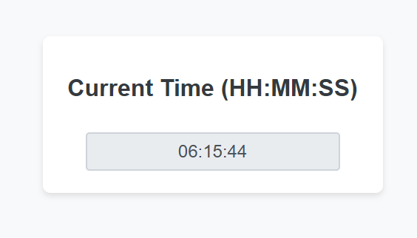
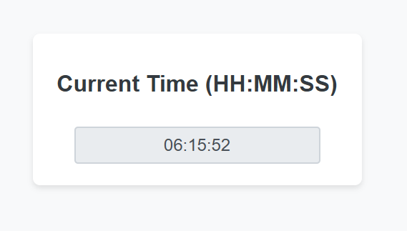

Assignment 3

1.
Write validation functions and modify the onSubmit event Handler in the form code to validate the following form fields:
- Member number
  - Must be entered
  - Must be a number
- Password
  - Must be entered
  - Must be longer than 4 characters
If an error occurs, use an alert box to display an error message for the first field in error and place the cursor in the first field in error.
<!DOCTYPE html>
<html lang="en">
<head>
<meta charset="UTF-8">
<meta name="viewport" content="width=device-width, initial-scale=1.0">
<title>Form Validation with Alert</title>
<style>
body {
font-family: Arial, sans-serif;
background-color: #f4f7f9;
display: flex;
justify-content: center;
align-items: center;
min-height: 100vh;
margin: 0;
}
.container {
background-color: #fff;
padding: 30px 40px;
border-radius: 10px;
box-shadow: 0 4px 15px rgba(0, 0, 0, 0.1);
width: 100%;
max-width: 450px;
}
h1 {
text-align: center;
color: #333;
margin-bottom: 20px;
}
.form-group {
margin-bottom: 20px;
}
label {
display: block;
margin-bottom: 5px;
font-weight: bold;
color: #555;
}
input, input[type="password"] {
width: 100%;
padding: 10px;
border: 1px solid #ccc;
border-radius: 5px;
box-sizing: border-box;
font-size: 16px;
}
.success-message {
color: #5cb85c;
font-size: 16px;
text-align: center;
margin-top: 20px;
display: none;
font-weight: bold;
}
button {
width: 100%;
padding: 12px;
background-color: #007bff;
color: white;
border: none;
border-radius: 5px;
cursor: pointer;
font-size: 18px;
transition: background-color 0.3s ease;
}
button:hover {
background-color: #0056b3;
}
</style>
</head>
<body>
<div class="container">
<h1>Member Form</h1>
<form id="myForm">
<div class="form-group">
<label for="memberNumber">Member number</label>
<input type="text" id="memberNumber" name="memberNumber">
</div>
<div class="form-group">
<label for="password">Password</label>
<input type="password" id="password" name="password">
</div>
<button type="submit">Submit</button>
</form>
<p id="successMessage" class="success-message">Form submitted successfully!</p>
</div>

<script>
document.getElementById('myForm').addEventListener('submit', function(event) {
// Prevent the form from submitting by default
event.preventDefault();
document.getElementById('successMessage').style.display = 'none';

let memberNumber = document.getElementById('memberNumber');
let password = document.getElementById('password');

// Validation for Member number
if (memberNumber.value.trim() === '') {
alert('Member number must be entered.');
memberNumber.focus();
return;
}
if (isNaN(memberNumber.value)) {
alert('Member number must be a number.');
memberNumber.focus();
return;
}

// Validation for Password
if (password.value.trim() === '') {
alert('Password must be entered.');
password.focus();
return;
}
if (password.value.length <= 4) {
alert('Password must be longer than 4 characters.');
password.focus();
return;
}

// If all validations pass
document.getElementById('successMessage').style.display = 'block';
});
</script>
</body>
</html>

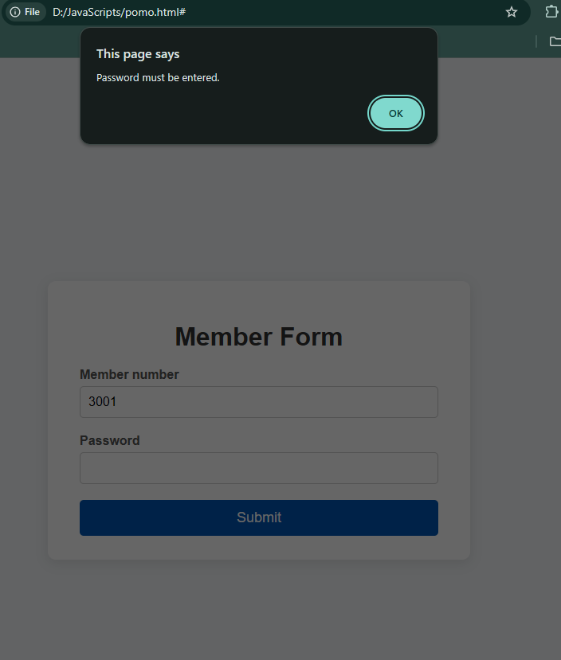
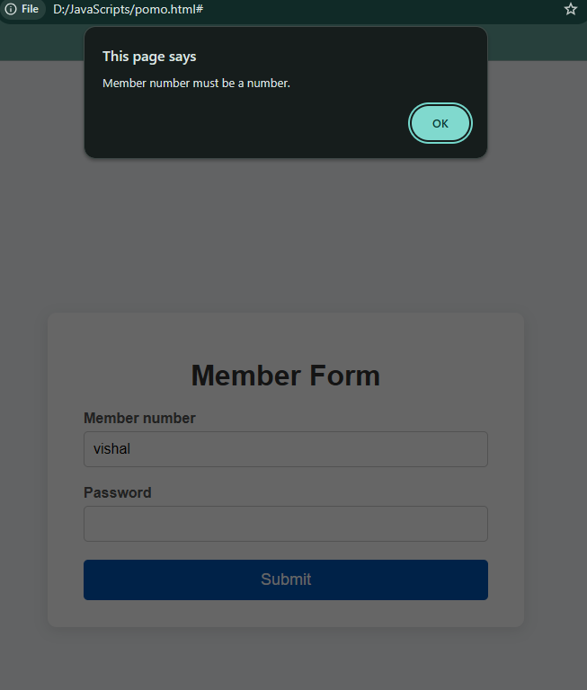
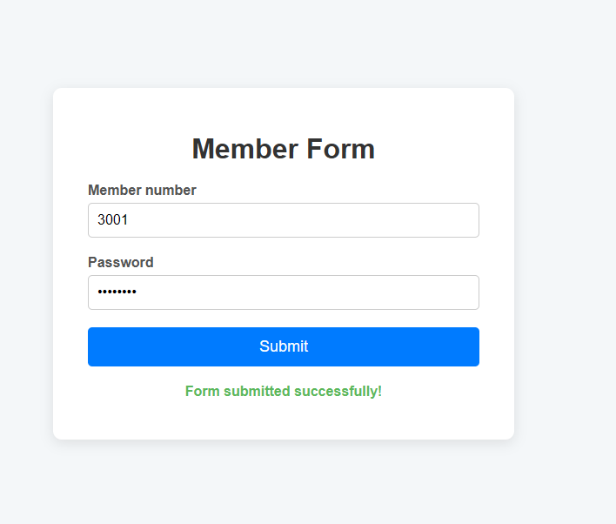

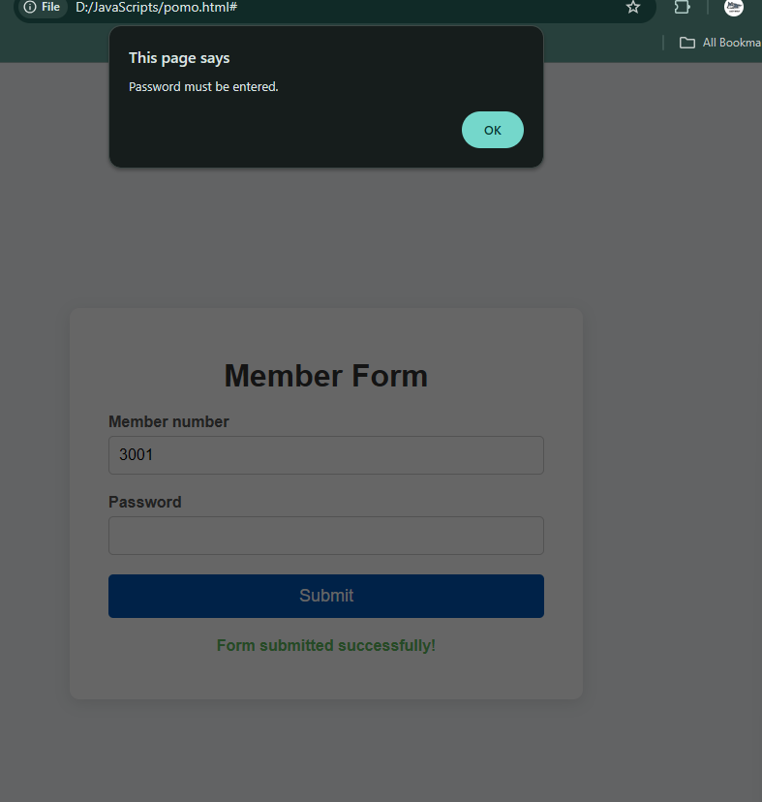

2
Write validation functions and modify the onSubmit event Handler in the form code to validate the following form fields:
- Phone Number
  - Must be entered
  - Must be in below format
XXX-XXX-XXXX
XXX.XXX.XXXX
XXXXXXXXXX
Code:
<!DOCTYPE html>
<html lang="en">
<head>
<meta charset="UTF-8">
<meta name="viewport" content="width=device-width, initial-scale=1.0">
<title>Phone Number Validation</title>
<style>
body {
font-family: Arial, sans-serif;
background-color: #f4f7f9;
display: flex;
justify-content: center;
align-items: center;
min-height: 100vh;
margin: 0;
}
.container {
background-color: #fff;
padding: 30px 40px;
border-radius: 10px;
box-shadow: 0 4px 15px rgba(0, 0, 0, 0.1);
width: 100%;
max-width: 450px;
}
h1 {
text-align: center;
color: #333;
margin-bottom: 20px;
}
.form-group {
margin-bottom: 20px;
}
label {
display: block;
margin-bottom: 5px;
font-weight: bold;
color: #555;
}
input {
width: 100%;
padding: 10px;
border: 1px solid #ccc;
border-radius: 5px;
box-sizing: border-box;
font-size: 16px;
}
.result-message {
font-size: 16px;
text-align: center;
margin-top: 20px;
display: none;
font-weight: bold;
}
.success-message {
color: #5cb85c;
}
.error-message {
color: #d9534f;
}
button {
width: 100%;
padding: 12px;
background-color: #17a2b8;
color: white;
border: none;
border-radius: 5px;
cursor: pointer;
font-size: 18px;
transition: background-color 0.3s ease;
}
button:hover {
background-color: #138496;
}
</style>
</head>
<body>
<div class="container">
<h1>Phone Number Validation</h1>
<form id="phoneNumberForm">
<div class="form-group">
<label for="phoneNumber">Phone Number</label>
<input type="text" id="phoneNumber" name="phoneNumber" placeholder="e.g., XXX-XXX-XXXX">
</div>
<button type="submit">Validate</button>
</form>
<p id="validationMessage" class="result-message"></p>
</div>

<script>
document.getElementById('phoneNumberForm').addEventListener('submit', function(event) {
event.preventDefault();

const validationMessage = document.getElementById('validationMessage');
validationMessage.style.display = 'none';
validationMessage.classList.remove('success-message', 'error-message');

let phoneNumber = document.getElementById('phoneNumber');
let phoneValue = phoneNumber.value.trim();

if (phoneValue === '') {
validationMessage.innerText = 'Phone Number must be entered.';
validationMessage.classList.add('error-message');
validationMessage.style.display = 'block';
phoneNumber.focus();
return;
}

// Regex to check for formats: XXX-XXX-XXXX, XXX.XXX.XXXX, or XXXXXXXXXX
const regex = /^(\d{3}[-.\s]?\d{3}[-.\s]?\d{4})$/;
if (!regex.test(phoneValue)) {
validationMessage.innerText = 'Phone Number must be in a valid format (e.g., XXX-XXX-XXXX, XXX.XXX.XXXX, or XXXXXXXXXX).';
validationMessage.classList.add('error-message');
validationMessage.style.display = 'block';
phoneNumber.focus();
return;
}

validationMessage.innerText = 'Phone number is valid!';
validationMessage.classList.add('success-message');
validationMessage.style.display = 'block';
});
</script>
</body>
</html>
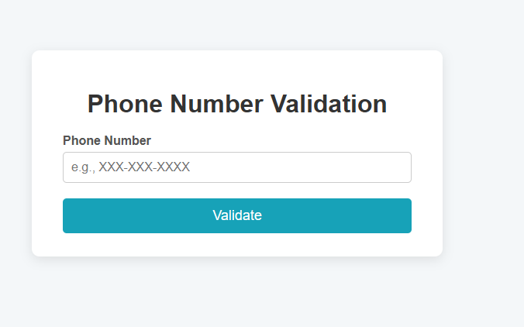

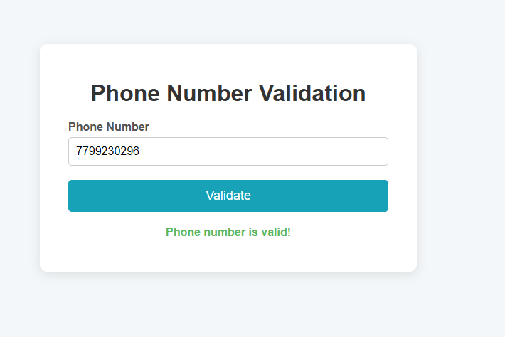
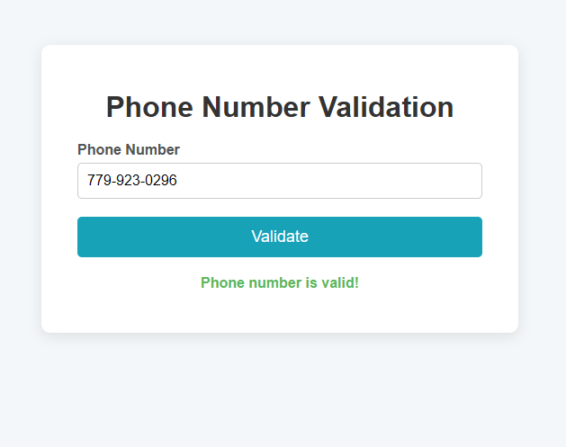
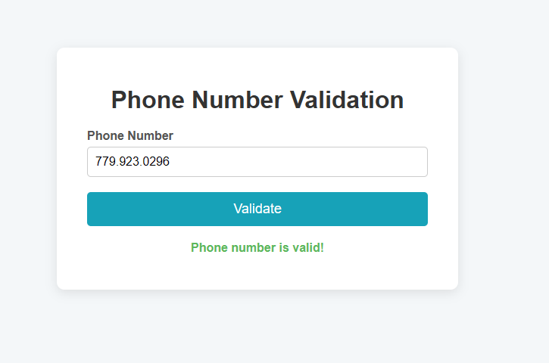

3
Write a validation function to check a password between 6 to 20 characters which contain at least one numeric digit, one uppercase and one lowercase letter.
<!DOCTYPE html>
<html lang="en">
<head>
<meta charset="UTF-8">
<meta name="viewport" content="width=device-width, initial-scale=1.0">
<title>Password Validation</title>
<style>
body {
font-family: Arial, sans-serif;
background-color: #f4f8ff;
text-align: center;
padding-top: 60px;
}

input {
padding: 10px;
font-size: 16px;
width: 250px;
border-radius: 5px;
border: 1px solid #ccc;
}

button {
padding: 10px 20px;
font-size: 16px;
border: none;
border-radius: 6px;
background-color: #007bff;
color: white;
cursor: pointer;
margin-left: 10px;
}

button:hover {
background-color: #0056b3;
}

p {
font-size: 18px;
margin-top: 20px;
}
</style>
</head>
<body>

<h2>🔐 Password Validation</h2>

<input type="password" id="password" placeholder="Enter password">
<button onclick="validatePassword()">Validate</button>

<p id="result"></p>

<script>
function validatePassword() {
let password = document.getElementById("password").value;
let result = document.getElementById("result");

// Regex pattern:
// - (?=.*\d) → at least one digit
// - (?=.*[a-z]) → at least one lowercase
// - (?=.*[A-Z]) → at least one uppercase
// - .{6,20} → total length between 6 to 20
let pattern = /^(?=.*\d)(?=.*[a-z])(?=.*[A-Z]).{6,20}$/;

if (pattern.test(password)) {
result.style.color = "green";
result.innerHTML = "✅ Password is valid!";
} else {
result.style.color = "red";
result.innerHTML = "❌ Invalid password!<br>Must be 6–20 characters and include at least one uppercase letter, one lowercase letter, and one digit.";
}
}
</script>

</body>
</html>

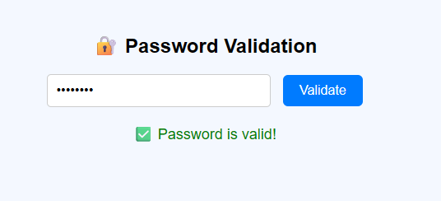

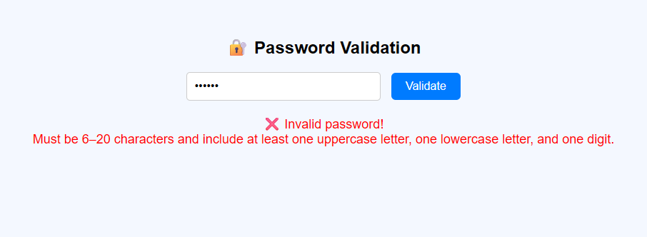

1.
Download bootstrap files as source files from the given location
http://getbootstrap.com/

<!DOCTYPE html>
<html lang="en">
<head>
<meta charset="UTF-8">
<meta name="viewport" content="width=device-width, initial-scale=1.0">
<title>Download Bootstrap Source Files</title>
</head>
<body>
<h2>Download Bootstrap Source Files using JavaScript</h2>
<button id="downloadBtn">Download Bootstrap</button>

<script>
document.getElementById("downloadBtn").addEventListener("click", () => {
// Official Bootstrap Source URL
const bootstrapUrl = "https://github.com/twbs/bootstrap/archive/refs/heads/main.zip";

// Create a hidden link element
const link = document.createElement("a");
link.href = bootstrapUrl;
link.download = "bootstrap-source.zip"; // Suggests filename
document.body.appendChild(link);

// Trigger the download
link.click();

// Remove the element afterward
document.body.removeChild(link);

alert("Your Bootstrap source file download has started!");
});
</script>
</body>
</html>

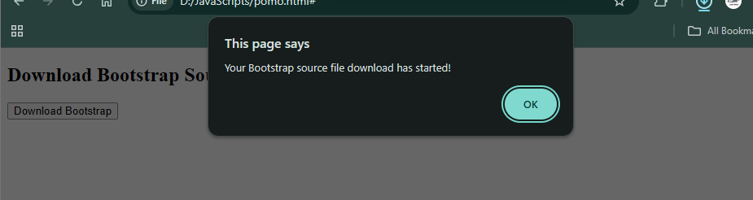

2.Unzip the contents and add the right files in the correct location of your MyExercise dynamic web project in eclipse

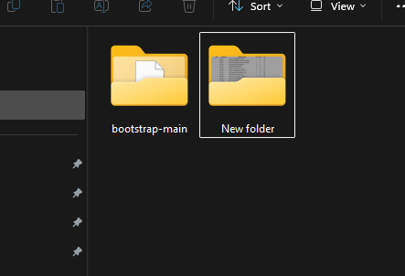

3.
Create a OldLook.html web page in the current project with the following content
Tags - Contents
H1 - Welcome to my page
P - this is a trial for bootstrap
Table
TR
TH - col1
TH - col2
TR
TD - data1
TD - data2
TR
TD - data3
TD - data4

<!DOCTYPE html>
<html lang="en">
<head>
<meta charset="UTF-8">
<meta name="viewport" content="width=device-width, initial-scale=1.0">
<title>Old Look Page (with Bootstrap)</title>

<!-- Bootstrap CSS -->
<link rel="stylesheet" href="css/bootstrap.min.css">
</head>
<body class="bg-light">

<div class="container mt-5">
<div class="text-center mb-4">
<h1 class="text-primary">Welcome to my page</h1>
<p class="lead">This is a trial for Bootstrap</p>
</div>

<div class="table-responsive">
<table class="table table-bordered table-striped text-center">
<thead class="table-dark">
<tr>
<th>col1</th>
<th>col2</th>
</tr>
</thead>
<tbody>
<tr>
<td>data1</td>
<td>data2</td>
</tr>
<tr>
<td>data3</td>
<td>data4</td>
</tr>
</tbody>
</table>
</div>
</div>

<!-- Bootstrap JS -->
<script src="js/bootstrap.bundle.min.js"></script>
</body>
</html>

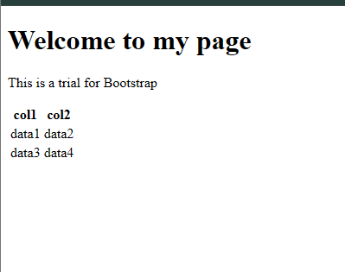

4
Create a NewLook.html web page in the current project with the contents of the previous exercise along with the stylesheet reference of css/bootstrap.min.css Observe the difference if any.

<!DOCTYPE html>
<html lang="en">
<head>
<meta charset="UTF-8">
<meta name="viewport" content="width=device-width, initial-scale=1.0">
<title>My New Look Page</title>
<!-- Add the Bootstrap CSS stylesheet link -->
<link rel="stylesheet" href="css/bootstrap.min.css">
<style>
body {
padding: 20px;
}
.container {
max-width: 800px;
margin: auto;
padding: 20px;
}
h1 {
text-align: center;
}
p {
text-align: center;
}
</style>
</head>
<body>
<div class="container">
<h1>Welcome to my page</h1>
<p>this is a trial for bootstrap</p>

<table class="table table-bordered table-striped">
<thead>
<tr>
<th>col1</th>
<th>col2</th>
</tr>
</thead>
<tbody>
<tr>
<td>data1</td>
<td>data2</td>
</tr>
<tr>
<td>data3</td>
<td>data4</td>
</tr>
</tbody>
</table>
</div>
</body>
</html>

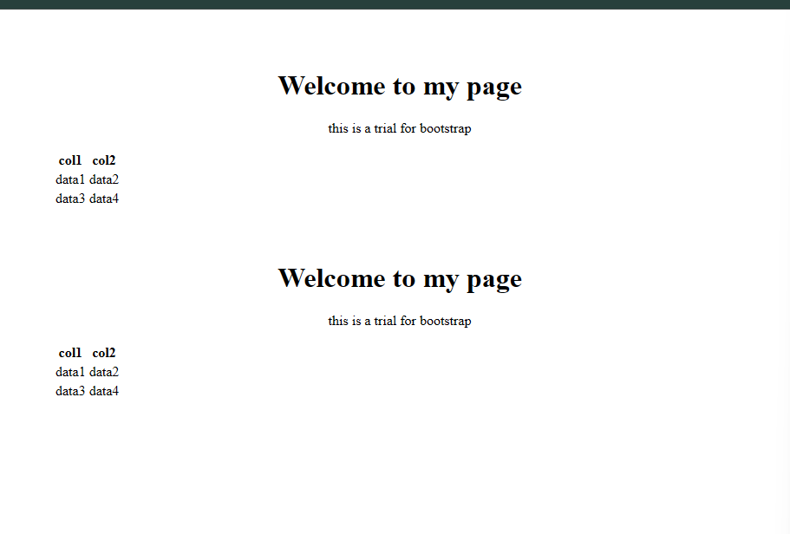

5
Explore more behaviors with different html tags
<!DOCTYPE html>
<html lang="en">
<head>
<meta charset="UTF-8">
<meta name="viewport" content="width=device-width, initial-scale=1.0">
<title>Exploring More Tags</title>
<style>
body {
font-family: Arial, sans-serif;
background-color: #f4f7f9;
padding: 20px;
line-height: 1.6;
}
.container {
max-width: 800px;
margin: auto;
background-color: #fff;
padding: 30px;
border-radius: 8px;
box-shadow: 0 4px 12px rgba(0,0,0,0.1);
}
h1, h2 {
color: #333;
}
ul, ol {
margin-bottom: 20px;
}
button {
padding: 10px 15px;
background-color: #007BFF;
color: white;
border: none;
border-radius: 5px;
cursor: pointer;
margin-top: 10px;
}
a {
color: #007BFF;
text-decoration: none;
}
a:hover {
text-decoration: underline;
}
</style>
</head>
<body>
<div class="container">
<h1>Exploring More HTML Tags</h1>
<p>Here are some examples of different HTML tags and their behaviors.</p>

<h2>Buttons</h2>
<p>Buttons are used to create interactive elements that can be clicked.</p>
<button onclick="alert('Button clicked!')">Click Me!</button>

<h2>Ordered List</h2>
<ol>
<li>First item</li>
<li>Second item</li>
<li>Third item</li>
</ol>

<h2>Unordered List</h2>
<ul>
<li>Item A</li>
<li>Item B</li>
<li>Item C</li>
</ul>

<h2>Image Tag</h2>
<p>The `&lt;img&gt;` tag is used to embed an image into an HTML page.</p>
<img src="https://via.placeholder.com/150" alt="Placeholder Image">

<h2>Link Tag</h2>
<p>The `&lt;a&gt;` tag is used to create a hyperlink to another web page or resource.</p>
<p><a href="https://www.google.com" target="_blank">Visit Google</a></p>
</div>
</body>
</html>
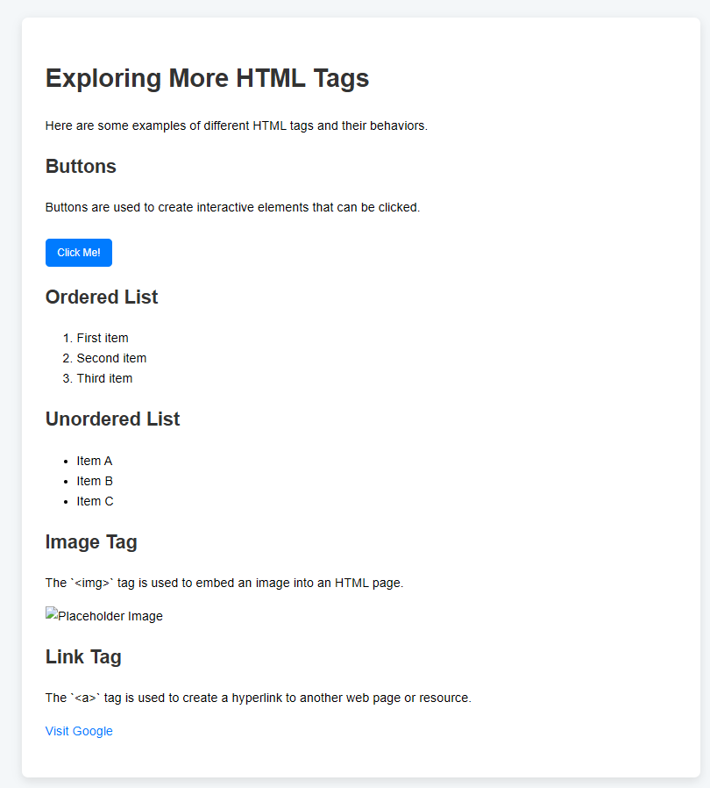

1.
Create a webpage which displays different images on screen as you resize the browser Take 4 images like img1.jpg, img2.jpg, img3.jpg, img4.jpg which should be displayed on the web page and only one should be visible at any time as you keep resizing the screen it should start changing to img2 and then to img3 and so on.
<!DOCTYPE html>
<html lang="en">
<head>
<meta charset="UTF-8">
<meta name="viewport" content="width=device-width, initial-scale=1.0">
<title>Responsive Image</title>
<style>
body {
font-family: Arial, sans-serif;
background-color: #f4f4f4;
text-align: center;
padding: 20px;
}
.container {
max-width: 900px;
margin: auto;
background-color: #fff;
padding: 20px;
border-radius: 8px;
box-shadow: 0 4px 8px rgba(0,0,0,0.1);
}
h1 {
color: #333;
}
p {
font-size: 18px;
color: #555;
}
#responsive-image {
max-width: 100%;
height: auto;
margin-top: 20px;
border: 2px solid #ddd;
}
</style>
</head>
<body>
<div class="container">
<h1>Responsive Image Display</h1>
<p>Resize the browser window to see the image change.</p>
<img id="responsive-image" src="Infinite Power.png" alt="Dynamic Image">
</div>

<script>
function changeImage() {
const width = window.innerWidth;
const imgElement = document.getElementById('responsive-image');

if (width > 768) {
imgElement.src = 'Jungle.png';
} else if (width > 480) {
imgElement.src = 'a cute and techy dragon working on a PC.PNG';
} else if (width > 320) {
imgElement.src = 'pexels-walid-ahmad-847402.jpg';
} else {
imgElement.src = 'w9mxtrr77bi21.png';
}
}
window.addEventListener('resize', changeImage);
changeImage();
</script>
</body>
</html>

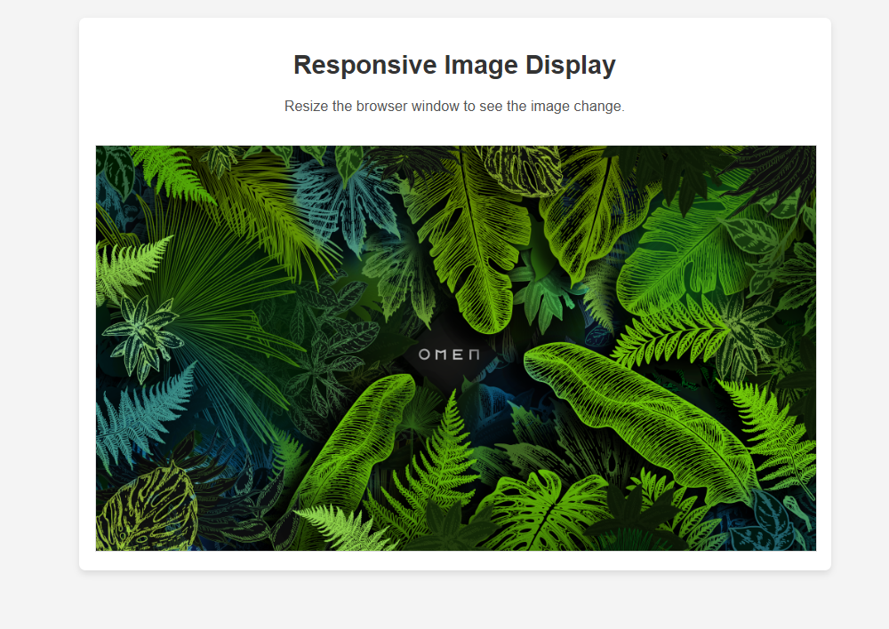
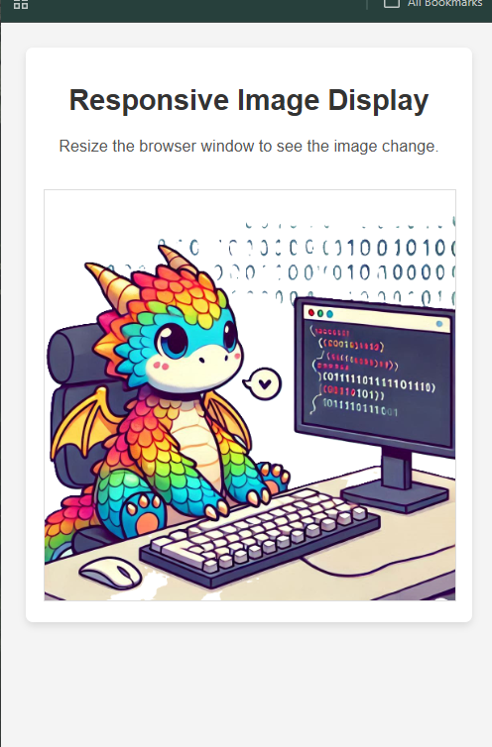

2.
Create a small table with 2 columns Name and contact no, Populate the table with 5 of your friends names and their contact nos. When the mouse is taken over the table it should highlight the row where the mouse is placed. (hint: use table hover)
<!DOCTYPE html>
<html lang="en">
<head>
<meta charset="UTF-8">
<meta name="viewport" content="width=device-width, initial-scale=1.0">
<title>Contact List</title>
<style>
body {
font-family: Arial, sans-serif;
background-color: #f4f4f4;
text-align: center;
padding: 20px;
}
.container {
max-width: 600px;
margin: auto;
background-color: #fff;
padding: 20px;
border-radius: 8px;
box-shadow: 0 4px 8px rgba(0,0,0,0.1);
}
h1 {
color: #333;
}
table {
width: 100%;
border-collapse: collapse;
margin-top: 20px;
}
th, td {
border: 1px solid #ddd;
padding: 12px;
text-align: left;
}
th {
background-color: #007BFF;
color: white;
}
tr:hover {
background-color: #f1f1f1;
}
</style>
</head>
<body>
<div class="container">
<h1>Friends' Contact List</h1>
<table>
<thead>
<tr>
<th>Name</th>
<th>Contact no</th>
</tr>
</thead>
<tbody>
<tr>
<td>John Doe</td>
<td>123-456-7890</td>
</tr>
<tr>
<td>Jane Smith</td>
<td>098-765-4321</td>
</tr>
<tr>
<td>Peter Jones</td>
<td>111-222-3333</td>
</tr>
<tr>
<td>Sarah Williams</td>
<td>444-555-6666</td>
</tr>
<tr>
<td>Michael Brown</td>
<td>777-888-9999</td>
</tr>
</body>
</table>
</div>
</body>
</html>

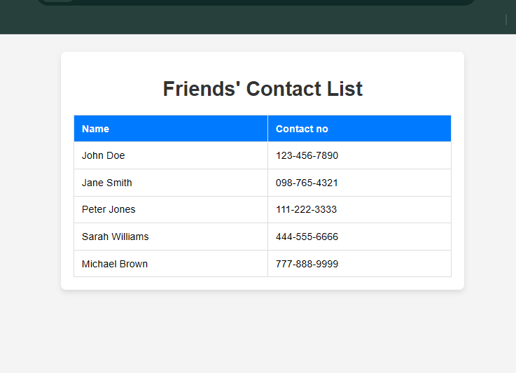
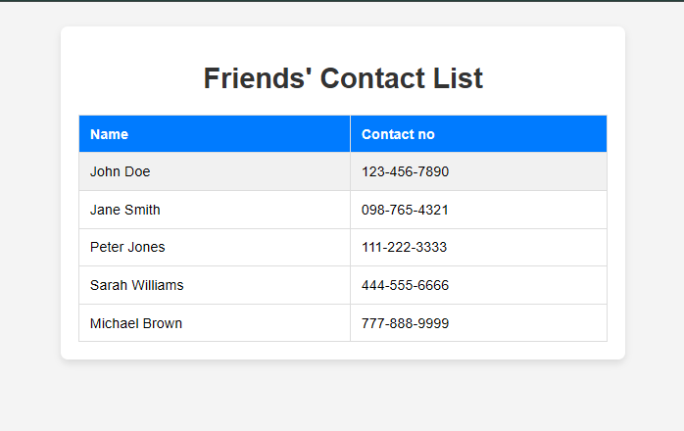

3
Create a table of food contents with its calorie value. Display the rows of food contents with calories <=300 in light green background, 301 to 700 in light blue, 700 1200 in light orange >1200 in light red. (Hint: use table table-striped).

<!DOCTYPE html>
<html lang="en">
<head>
<meta charset="UTF-8">
<meta name="viewport" content="width=device-width, initial-scale=1.0">
<title>Calorie Table</title>
<style>
body {
font-family: Arial, sans-serif;
background-color: #f4f4f4;
text-align: center;
padding: 20px;
}
.container {
max-width: 600px;
margin: auto;
background-color: #fff;
padding: 20px;
border-radius: 8px;
box-shadow: 0 4px 8px rgba(0,0,0,0.1);
}
h1 {
color: #333;
}
table {
width: 100%;
border-collapse: collapse;
margin-top: 20px;
}
th, td {
border: 1px solid #ddd;
padding: 12px;
text-align: left;
}
th {
background-color: #6c757d;
color: white;
}
.bg-green {
background-color: #d4edda;
}
.bg-blue {
background-color: #cce5ff;
}
.bg-orange {
background-color: #fff3cd;
}
.bg-red {
background-color: #f5c6cb;
}
</style>
</head>
<body>
<div class="container">
<h1>Food Calorie Chart</h1>
<table>
<thead>
<tr>
<th>Food Content</th>
<th>Calorie Value</th>
</tr>
</thead>
<tbody>
<tr data-calories="250">
<td>Apple</td>
<td>250</td>
</tr>
<tr data-calories="500">
<td>Chicken Breast</td>
<td>500</td>
</tr>
<tr data-calories="900">
<td>Pizza Slice</td>
<td>900</td>
</tr>
<tr data-calories="1300">
<td>Burger with Fries</td>
<td>1300</td>
</tr>
<tr data-calories="350">
<td>Salad</td>
<td>350</td>
</tr>
</tbody>
</table>
</div>

<script>
window.onload = function() {
const rows = document.querySelectorAll('tr[data-calories]');
rows.forEach(row => {
const calories = parseInt(row.getAttribute('data-calories'));
if (calories <= 300) {
row.classList.add('bg-green');
} else if (calories > 300 && calories <= 700) {
row.classList.add('bg-blue');
} else if (calories > 700 && calories <= 1200) {
row.classList.add('bg-orange');
} else if (calories > 1200) {
row.classList.add('bg-red');
}
});
};
</script>
</body>
</html>

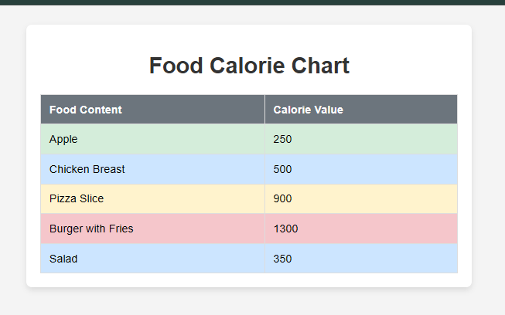
4
Create a webpage to display Tulips.jpg from sample pictures of your machine. Ensure the image has soft round edges and as you resize the screen, the image should also resize itself and fit its display to full page size.

<!DOCTYPE html>
<html lang="en">
<head>
<meta charset="UTF-8">
<meta name="viewport" content="width=device-width, initial-scale=1.0">
<title>Tulips</title>
<style>
body {
margin: 0;
padding: 0;
background-color: #f0f0f0;
display: flex;
justify-content: center;
align-items: center;
min-height: 100vh;
}
.image-container {
max-width: 100%;
height: auto;
overflow: hidden;
display: flex;
justify-content: center;
align-items: center;
}
.responsive-image {
width: 100%;
height: auto;
border-radius: 15px; /* Soft round edges */
box-shadow: 0 4px 8px rgba(0, 0, 0, 0.1);
}
</style>
</head>
<body>
<div class="image-container">
<!-- Assuming 'Tulips.jpg' is in the same directory as this HTML file -->
<img src="Tulips.jpg" alt="Tulips" class="responsive-image">
</div>
</body>
</html>

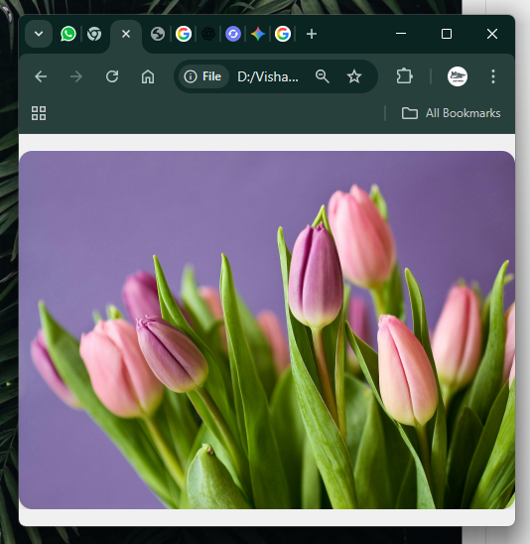

5.
Create a webpage called OnlineRead with give look and feel
Page should display Book Types as buttons with given background effect:
For All - white
Kids - dark blue
Teens - Green
Scientific - Light Blue
Crime - Orange
Horror - red
Feedback - shown
In next line display the comfort font size with buttons of varying sizes ranging from big to small (in 4 steps)

<!DOCTYPE html>
<html lang="en">
<head>
<meta charset="UTF-8">
<meta name="viewport" content="width=device-width, initial-scale=1.0">
<title>OnlineRead</title>
<style>
body {
font-family: Arial, sans-serif;
background-color: #f4f7f9;
padding: 20px;
text-align: center;
transition: font-size 0.3s ease;
}
.container {
background-color: #fff;
padding: 30px;
border-radius: 10px;
box-shadow: 0 4px 8px rgba(0, 0, 0, 0.1);
max-width: 800px;
margin: auto;
}
h1 {
color: #333;
margin-bottom: 20px;
}
.book-types, .font-size-controls {
margin-bottom: 30px;
}
.book-types button {
color: black;
border: 1px solid #ccc;
padding: 10px 20px;
margin: 5px;
border-radius: 5px;
cursor: pointer;
font-size: 16px;
}
#btn-all { background-color: white; }
#btn-kids { background-color: darkblue; color: white; }
#btn-teens { background-color: green; color: white; }
#btn-scientific { background-color: lightblue; }
#btn-crime { background-color: orange; }
#btn-horror { background-color: red; color: white; }

.font-size-controls button {
border: 1px solid #ccc;
padding: 10px 15px;
margin: 5px;
border-radius: 5px;
cursor: pointer;
font-weight: bold;
}
#font-size-big { font-size: 24px; }
#font-size-large { font-size: 20px; }
#font-size-medium { font-size: 16px; }
#font-size-small { font-size: 12px; }
</style>
</head>
<body>
<div class="container">
<h1>OnlineRead</h1>

<div class="book-types">
<h3>Book Types</h3>
<button id="btn-all">For All</button>
<button id="btn-kids">Kids</button>
<button id="btn-teens">Teens</button>
<button id="btn-scientific">Scientific</button>
<button id="btn-crime">Crime</button>
<button id="btn-horror">Horror</button>
</div>

<div class="font-size-controls">
<h3>Comfort Font Size</h3>
<button id="btn-big" onclick="changeFontSize(24)">Big</button>
<button id="btn-large" onclick="changeFontSize(20)">Large</button>
<button id="btn-medium" onclick="changeFontSize(16)">Medium</button>
<button id="btn-small" onclick="changeFontSize(12)">Small</button>
</div>
</div>

<script>
function changeFontSize(size) {
document.body.style.fontSize = size + 'px';
}
</script>
</body>
</html>

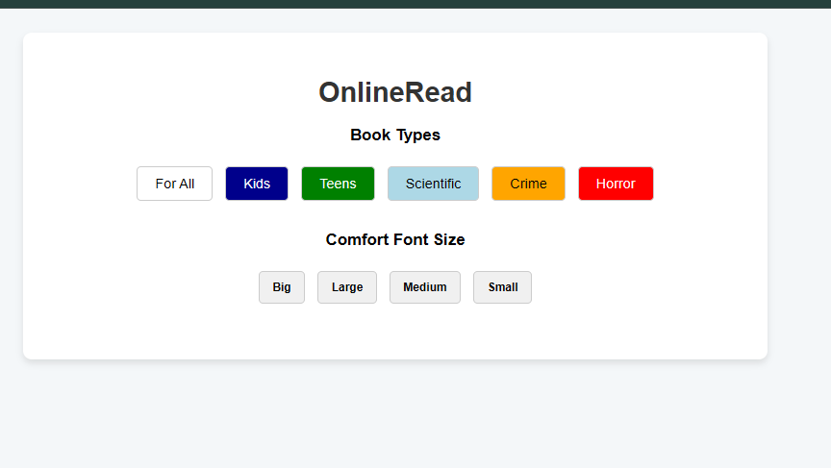
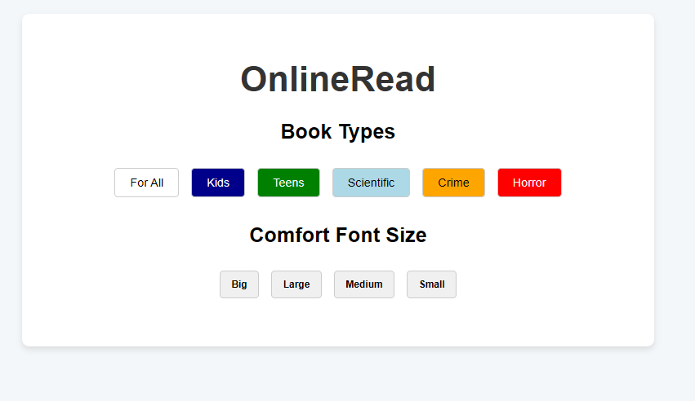
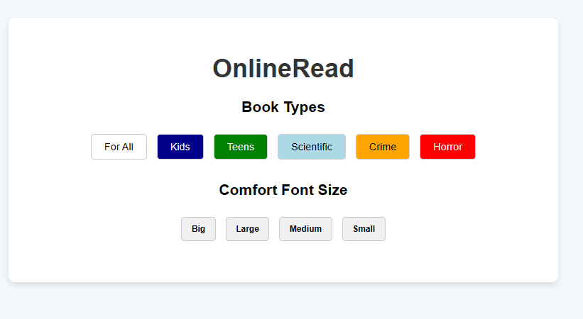
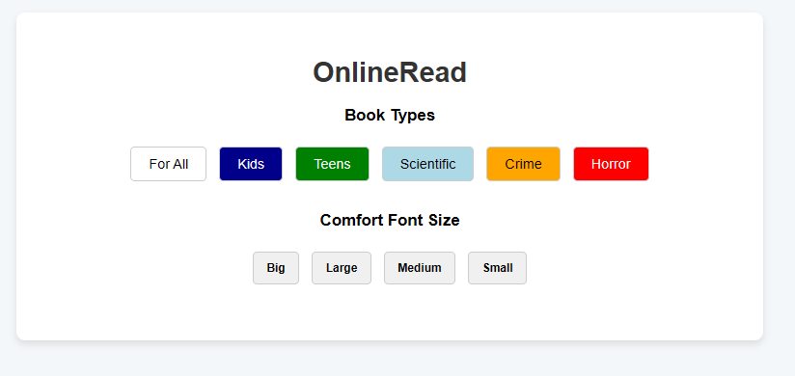
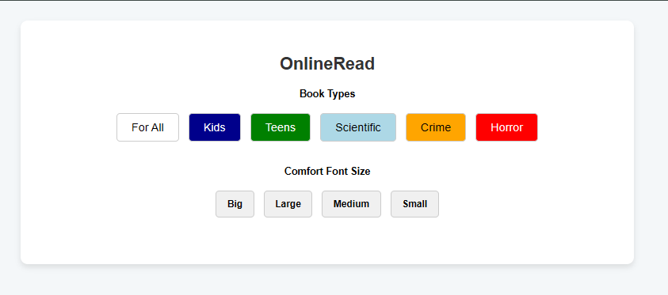
1.
Create a webpage with 4 grid sections containing Contents of some 10 lines. Ensure the grid alters itself as the browser is resized.

<!DOCTYPE html>
<html lang="en">
<head>
<meta charset="UTF-8">
<meta name="viewport" content="width=device-width, initial-scale=1.0">
<title>Responsive Grid</title>
<style>
body {
font-family: Arial, sans-serif;
margin: 0;
padding: 20px;
background-color: #f0f2f5;
}

.container {
display: grid;
gap: 20px;
}

.grid-item {
background-color: #ffffff;
border-radius: 8px;
box-shadow: 0 2px 4px rgba(0, 0, 0, 0.1);
padding: 20px;
box-sizing: border-box;
line-height: 1.6;
}

h1 {
text-align: center;
color: #333;
margin-bottom: 20px;
}

/* Large screens: 2x2 grid */
@media (min-width: 769px) {
.container {
grid-template-columns: repeat(2, 1fr);
}
}

/* Medium screens: 1x4 grid */
@media (min-width: 481px) and (max-width: 768px) {
.container {
grid-template-columns: 1fr;
}
}

/* Small screens: Single column, items take full width */
@media (max-width: 480px) {
.container {
grid-template-columns: 1fr;
}
}
</style>
</head>
<body>
<h1>Responsive Grid Layout</h1>

<div class="container">
<div class="grid-item">
<h2>Section 1</h2>
<p>
Lorem ipsum dolor sit amet, consectetur adipiscing elit. Sed do eiusmod tempor incididunt ut labore et dolore magna aliqua. Ut enim ad minim veniam, quis nostrud exercitation ullamco laboris nisi ut aliquip ex ea commodo consequat. Duis aute irure dolor in reprehenderit in voluptate velit esse cillum dolore eu fugiat nulla pariatur.
</p>
</div>
<div class="grid-item">
<h2>Section 2</h2>
<p>
Excepteur sint occaecat cupidatat non proident, sunt in culpa qui officia deserunt mollit anim id est laborum. Sed ut perspiciatis unde omnis iste natus error sit voluptatem accusantium doloremque laudantium, totam rem aperiam, eaque ipsa quae ab illo inventore veritatis et quasi architecto beatae vitae dicta sunt explicabo.
</p>
</div>
<div class="grid-item">
<h2>Section 3</h2>
<p>
Nemo enim ipsam voluptatem quia voluptas sit aspernatur aut odit aut fugit, sed quia consequuntur magni dolores eos qui ratione voluptatem sequi nesciunt. Neque porro quisquam est, qui dolorem ipsum quia dolor sit amet, consectetur, adipisci velit, sed quia non numquam eius modi tempora incidunt ut labore et dolore magnam aliquam quaerat voluptatem.
</p>
</div>
<div class="grid-item">
<h2>Section 4</h2>
<p>
Ut enim ad minima veniam, quis nostrum exercitationem ullam corporis suscipit laboriosam, nisi ut aliquid ex ea commodi consequatur? Quis autem vel eum iure reprehenderit qui in ea voluptate velit esse quam nihil molestiae consequatur, vel illum qui dolorem eum fugiat quo voluptas nulla pariatur?
</p>
</div>
</div>
</body>
</html>
